World Atlas
To open the atlas:
- Click on the World Atlas link here: World Atlas
- Right Click on the Atlas. Select Save As.
- Navigate to your student folder by clicking the Save In text box and find your folder. Make sure your folder name shows in the Save In box.
- Click the Save button located at the bottom of the dialog box.
Insert the World Atlas in Microsoft Word:
- Insert the Atlas into a new word document the same way you inserted pictures for assignment 1. Resize the picture so it is as big as possible.

Make textboxes and lines:
Once you find the country, you will insert a textbox in Microsoft Word by clicking the textbox button on the insert menu. The textbox is the button that has the capital A and lines.
- Open the textbox by clicking in the area around the map near the animal's habitat, and while holding down the left mouse, drag the textbox open. Type in the names of the animals that live in that region.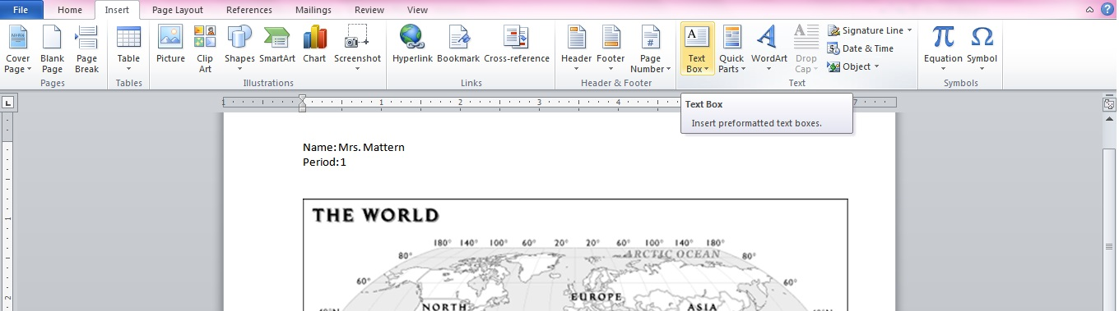
To add an arrow in Word:
Click Insert on the menu. Click Shapes (the button with light blue shapes). The first category is recently used, and the second is Lines. Pick whichever arrow type you want to use. Click on the textbox and drag the mouse to point at the country the animal lives in. You can resize the arrows or change their direction by clicking the line and dragging.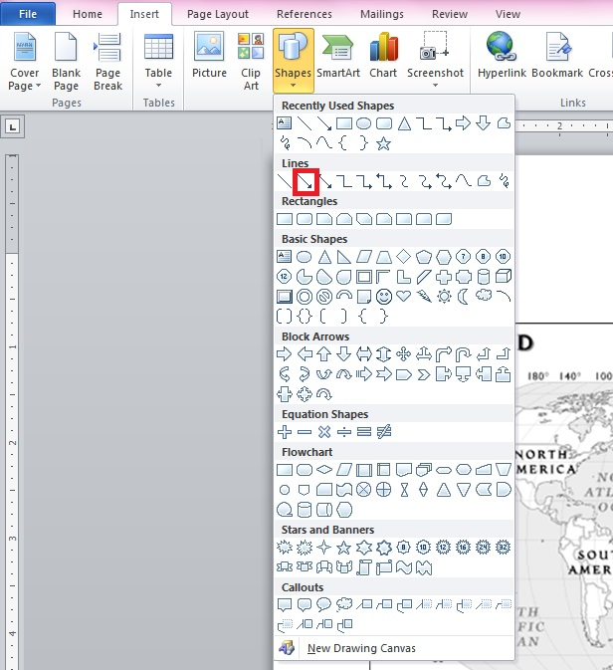
Assignment 1 and 2 are due on Thursday, August 22!

