Creating a Theme Park Brochure
Open Microsoft Publisher.
At the Getting Started with Microsoft Publisher 2007 page select under Publication Types select Brochures.
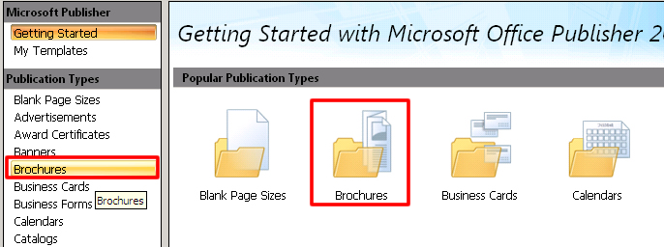
Select Informational for the type of your brochure. Choose the theme your prefer.
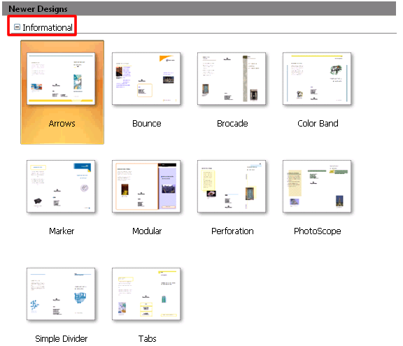
SAVE IT as lastname.brochure

You can customize your brochure by changing the color scheme, font scheme at the Customize options area located at the right hand side of your document window. Do not change the page size options or include a customor address.
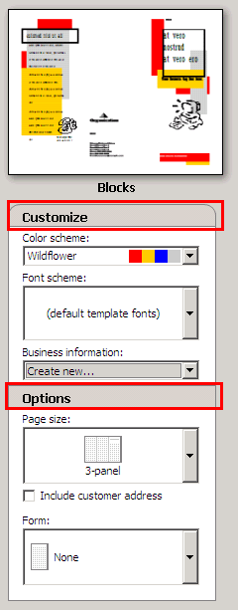
When you have finished customizing your font and color options click the Create button to begin adding the information you included in your worksheet. Make sure you fill in both sides of your brochure!!

