Creating Graphs in Excel
Open a new Excel worksheet. Name is “lastname.graph.xlsx”
Input Data:
Type in the following information in the correct cells shown below:
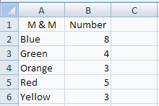
Now we are going to create a Pie graph
Create a 3D Pie Graph:
Select all the data in cells A2 through A6 and B2 through B6 by clicking and dragging the mouse across the cells.
Click the Insert tab and select Pie Chart:
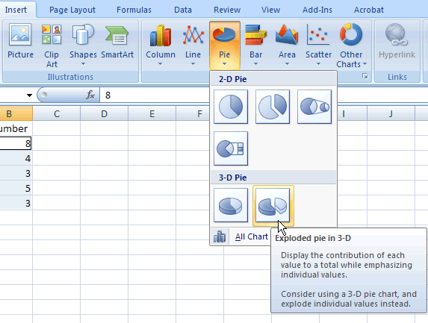
Your Pie Chart should now appear in your worksheet.
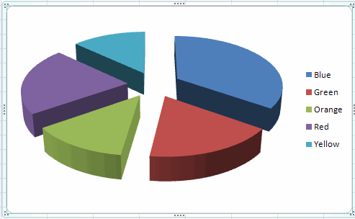
Change the colors:
Did you notice that the colors are different from what is in the data? To fix that, first click the color on the chart. There should be blue dots around the word.
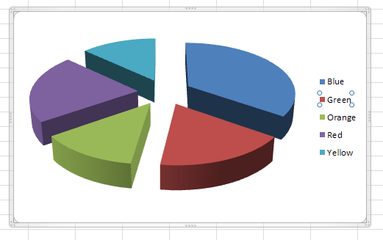
Next, select the format tab under Chart Tools. Select the color you want from Fill Color.
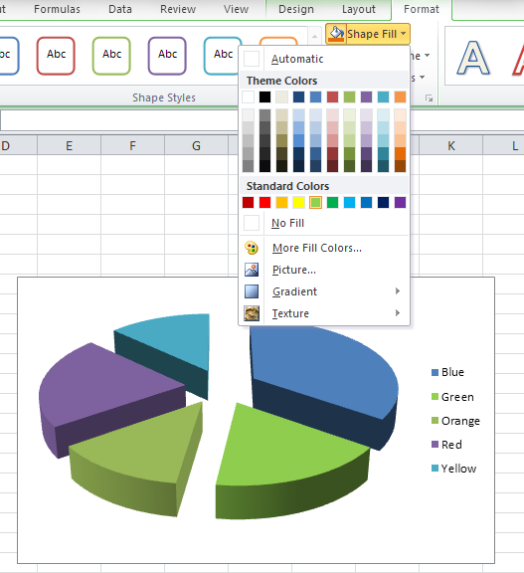
Do this for Orange, Red, and Yellow also.
Last, we need to make a title for our graph.
Click the Layout tab and select Chart Title. Type in your title “Number of Colored M&M’s in Bag” then save your Excel Worksheet.:
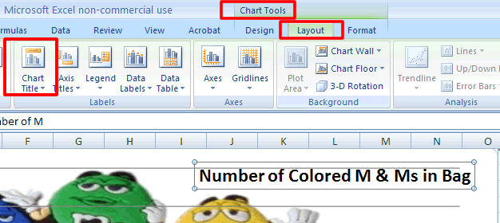
Your graph should look like this when you are done:
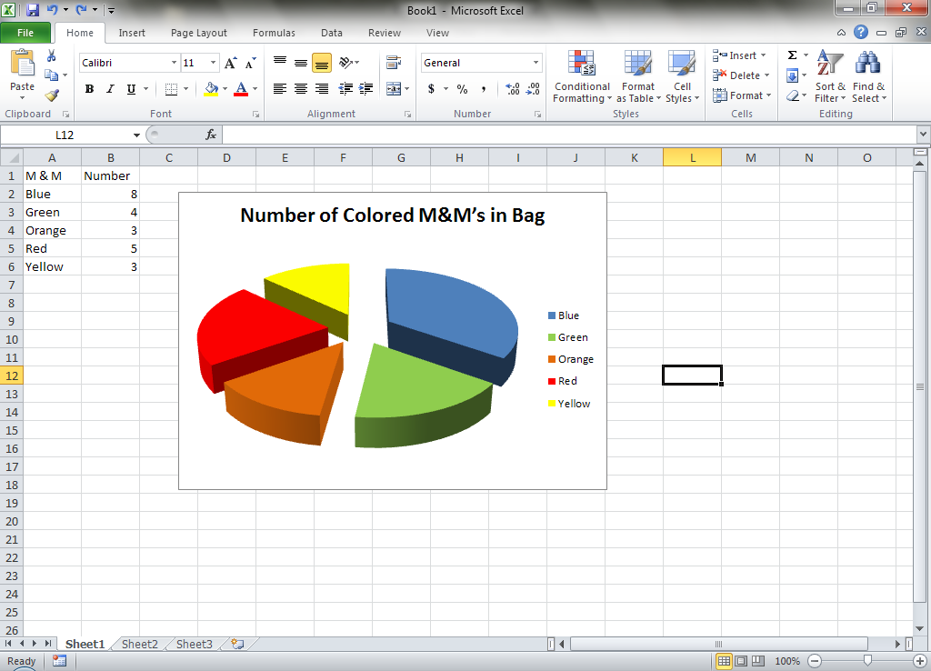

Next, I want you to do all of these steps but using a Column Graph instead. Make sure to change the colors and add a title! Thank you
The filename will be lastname.graph2.xlsx

