Animals From Around the World Lesson
Click on the "Animals From Around the World" worksheet and complete activity by following the directions. When you have completed the assignment, save it to your student folder and name it LastName . Animals
Happy Hunting!!!
FYI: The fastest way to find a specific topic on any web site is to conduct a search by typing in the name of the topic you want to find. Not all web sites offer this luxury, so use it when you can. It will save you a lot of time.
Directions for copying a picture from the Internet:
To copy a picture from the Web site, place your cursor directly on the picture you wish to copy, right click your mouse key, choose save as in your menu option box, a dialog box will pop up.
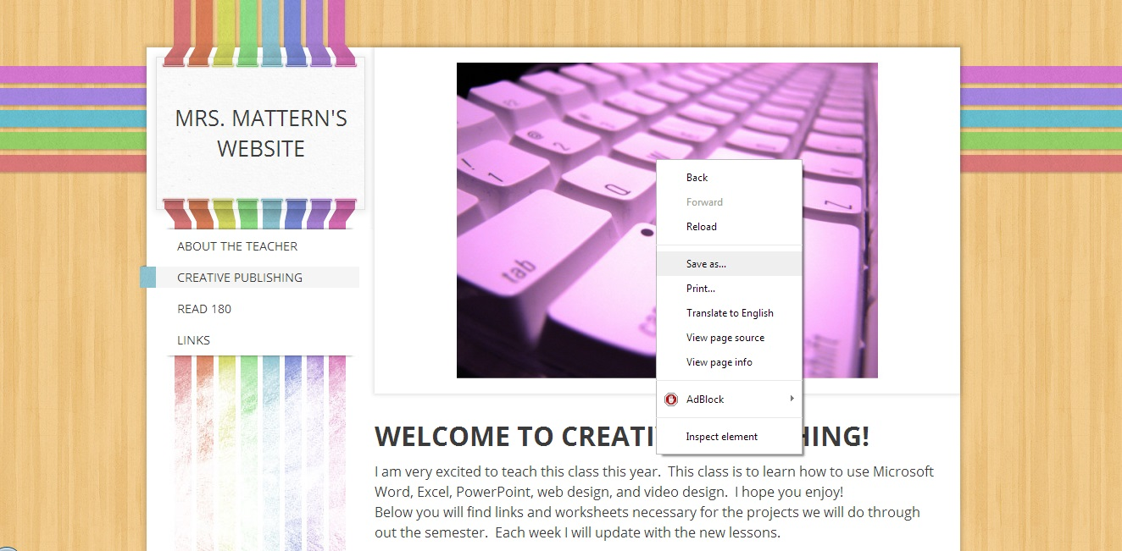

You will navigate to your student folder in the save in dialog box, then click in the name list box and type in the name of the animal you have copied.
Inserting a picture into a document:
Open up your Animals From Around the World Worksheet and place your cursor in the box that you want to place your picture in. From the menu bar, click insert, then picture, from file. A dialog box will appear. You then choose your student folder in the look in dialog box. A list of pictures will appear. Choose the picture you wish to paste into your table, then click insert. The picture should now appear in your table where you had placed your cursor initially.
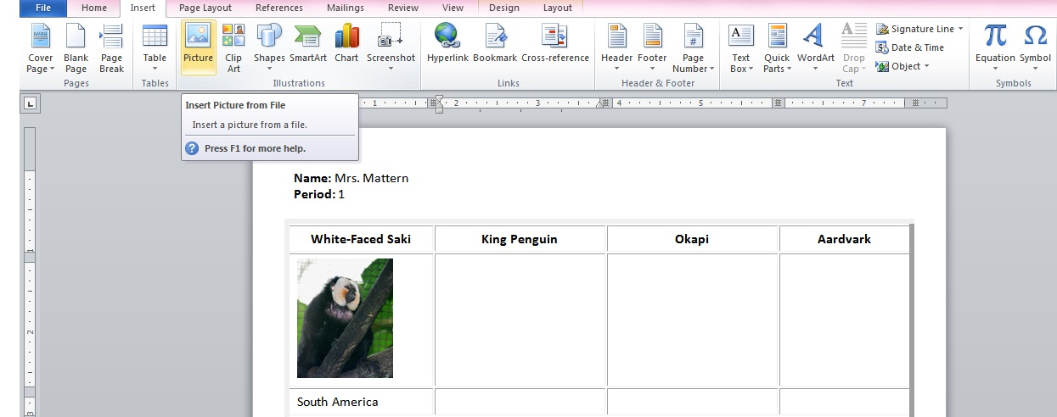
Re-sizing a Picture:
If you wish to make the picture larger or smaller, left click on the picture and a box with little squares will appear around the it. Place your cursor on one of squares until an arrow appears, then left click your mouse and drag your picture to make it appear the way you want it to. You can also change the appearance of your picture using the picture toolbar.
