If you could go visit any place in the world, where would you go? What would you do while you are there?
This week you get the chance to research and create a presentation about your favorite place in the world!
The first thing you need to do is research that place!
Now it is time to create the presentation!
First, open a new PowerPoint presentation. Save it to your server documents, and title it lastname.cruising (example, Mattern.cruising).
Adding Custom Animations
A custom animation is group of effects that can be added to an object in PowerPoint. In this lesson you will add custom animations to your PowerPoint presentation.
To get to the Custom Animation section, click the Animation tab.
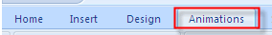
In the Animations panel select Custom Animation to open the Custom Animation panel.
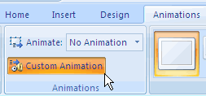
First select the object you wish to animate. For this activity you will click in the title Dress for Success title placeholder.
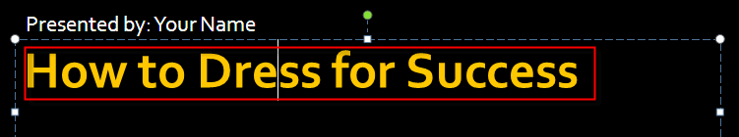
In the animation pane you will select an entrance animation. There are four effect types; Entrance, Emphasis, Exit, and Motion Paths.
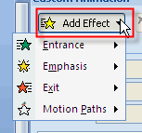
Click on Add Effect, then Entrance, then select an Entrance type.
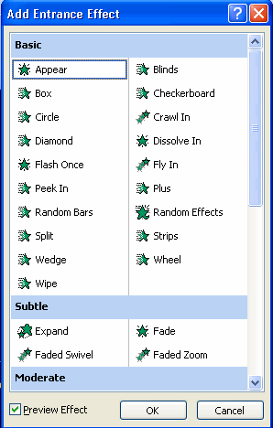
Click OK to apply the effect.
Next you will select a speed in which your animation will play.
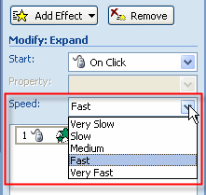
You will also determine how the animation will start. For this activity you will select On Click. When your mouse is clicked the effect will be played.
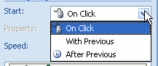
For more advanced animation options, double click the animation effect to open the advanced options dialog box.
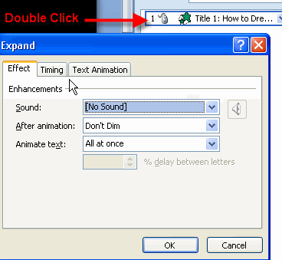
To remove the animation, click on the animation you want to remove, then click the remove button.
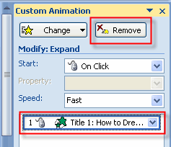
To reorder you animation simply click on the animation then click the up or down arrows at the bottom of the animation panel. To see your animations play click the play button.
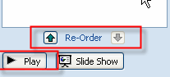
Add an Entrance Effect to your name placeholder on the title slide.
For slides 2 & 3 add an entrance effect to the title and an emphasis effect to the bulleted list.
For slide 4 add an entrance effect to the title and an exit effect to your bulleted list.
Resave the presentation.

Adding Custom Animations
Open the Dress for Success Slide Footers presentation you completed in the previous activity. Save this activity as Dress for Success with Animations. A custom animation is group of effects that can be added to an object in PowerPoint. In this lesson you will add custom animations to your PowerPoint presentation.
To get to the Custom Animation section, click the Animation tab.
In the Animations panel select Custom Animation to open the Custom Animation panel.
First select the object you wish to animate. For this activity you will click in the title Dress for Success title placeholder.
In the animation pane you will select an entrance animation. There are four effect types; Entrance, Emphasis, Exit, and Motion Paths.
Click on Add Effect, then Entrance, then select an Entrance type.
Click OK to apply the effect.
Next you will select a speed in which your animation will play.
You will also determine how the animation will start. For this activity you will select On Click. When your mouse is clicked the effect will be played.
For more advanced animation options, double click the animation effect to open the advanced options dialog box.
To remove the animation, click on the animation you want to remove, then click the remove button.
To reorder you animation simply click on the animation then click the up or down arrows at the bottom of the animation panel. To see your animations play click the play button.
Add an Entrance Effect to your name placeholder on the title slide.
For slides 2 & 3 add an entrance effect to the title and an emphasis effect to the bulleted list.
For slide 4 add an entrance effect to the title and an exit effect to your bulleted list.
Resave the presentation.

Apply Slide Transitions to Your Presentation
You will now apply slide transitions to your presentation. With the Animation tab selected you will find the Transition to Slides section.
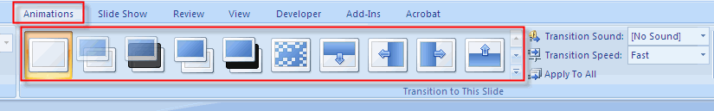
When applying transitions to slide you can do it for each slide or add the same transition to all of your slides. In this activity you will do both and then decide which one you prefer.
Add Different Slide Transitions to the Slides in Your Presentation
On the left side of the slide window, with the Slides tab selected, click the title thumbnail to select it.
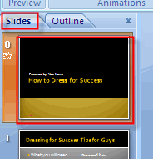
On the Animations tab, in the Transition To This Slide group, click the slide transition effect that you want for that slide.
To see more transition effects in the Quick Styles list, click the More button 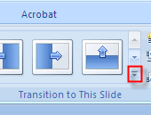.
To set the slide transition speed between the current slide and the next slide, in the Transition To This Slide group, click the arrow next to Transition Speed, and then select the speed that you want.
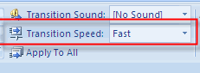
Continue adding transitions to the rest of your slides in the presentation.
Add the Same Slide Transition to All of the Slides in Your Presentation
On the left side of the slide window, in the pane that contains the Outline and Slides tabs, click the Slides tab.
Select the slide thumbnails of the slides that you want to apply slide transitions to.
On the Animations tab, in the Transition To This Slide group, click a slide transition effect.
To see more transition effects, in the Quick Styles list, click the More button .
To set the slide transition speed between the current slide and the next slide, in the Transition To This Slide group, click the arrow next to Transition Speed, and then select the speed that you want.
In the Transition To This Slide group, click Apply to All.
Add Sound to Slide Transitions
On the left side of the slide window, in the pane that contains the Outline and Slides tabs, click the Slides tab, and then select the slide thumbnails that you want to add a sound to.
On the Animations tab, in the Transition To This Slide group, click the arrow next to Transition Sound, and then do one of the following:
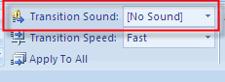
To add a sound from the list, select the sound that you want.
To add a sound not found on the list, select Other Sound, locate the sound file that you want to add, and then click OK.
To add sound to a different slide transition, repeat the steps above

