Mail Merge Form Letter and Recipient List
The Mail Merge Tool in Microsoft Word 2010 allows you to create unique, multiple versions of a customized "form letter." You will create a form letter using your letterhead, an envelope, and mailing labels for your customers.
When you have completed this activity you will have two separate items listed below.
- Mail Merge Form Letter
- Access Database of Your Customers
Create a form letter informing your customers on a upcoming event, special private sale, or some kind of promotion you want your customers to be informed about.
In Microsoft Word 2010, open your letterhead document.
Mail Merge Form Letter
Save the letterhead document into a new document by selecting Save As, finding your student folder, then saving with the name LastName.Mail Merge Form Letter.
On the Mailings tab, in the Start Mail Merge group, click Start Mail Merge then select Letters.
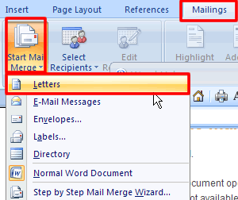.
Create Recipient List:
With the mailing tab still selected click Select Recipients then select Type New List.
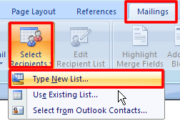
This opens the New Address List dialog box. You will type in five customer names. You can make these names and addresses up. You will need to include the following information:
- Title (Mr., Mrs., Ms., Dr.)
- First Name
- Last Name
- Address Line 1
- City
- State
- Zip Code
- E-mail Address
To begin a new name click the New Entry button at the bottom left hand side of the New Address List.
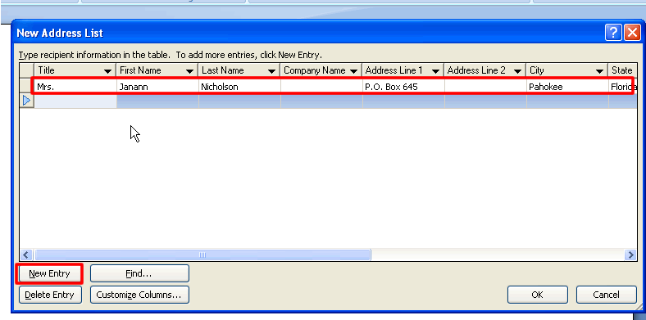
Click OK when you have entered all five of your customer name, addresses, and e-mail addresses. You will be prompted to save your customer database. Make sure that your My Business folder is in the Save in list and give it a unique name.
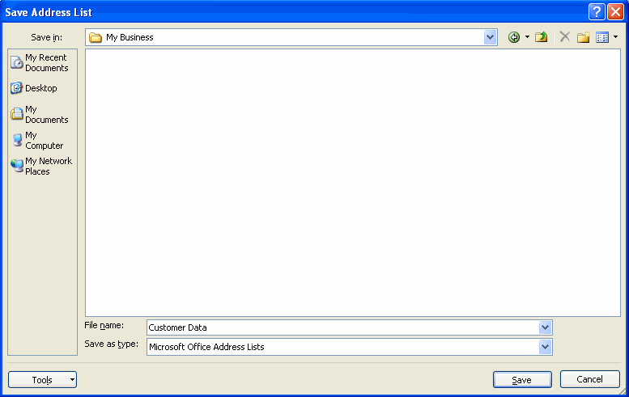
Insert Date & Time:
Now that all the recipients are created you will need to type out the form letter. The first thing you will insert is the date. With the Insert tab selected click on Date & Time.
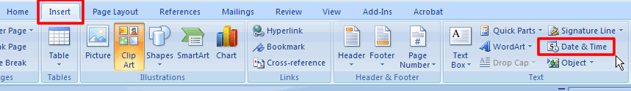
At the Date & Time dialog box choose the first date format and put a check in the Update Automatically.
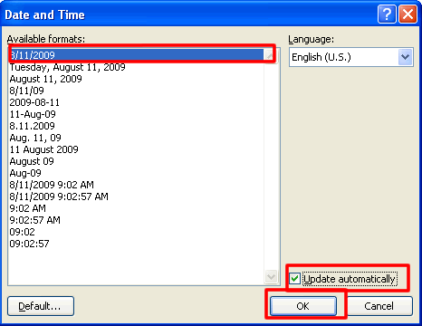
Your document should now look like this:
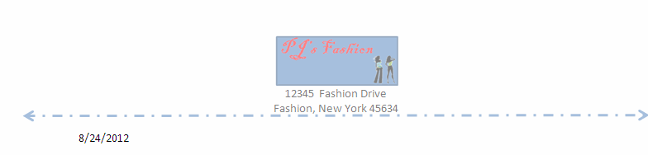
Include Address Block:
Next you will enter the addresses of the people you entered into your database. Double space down then click Address block and <<AddressBlock>> should appear two lines under the date.
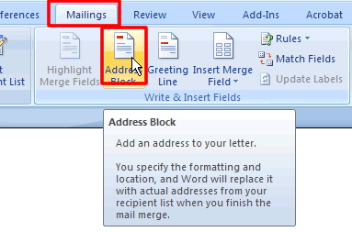
The address block dialog block will appear. Accept the defaults by clicking OK.
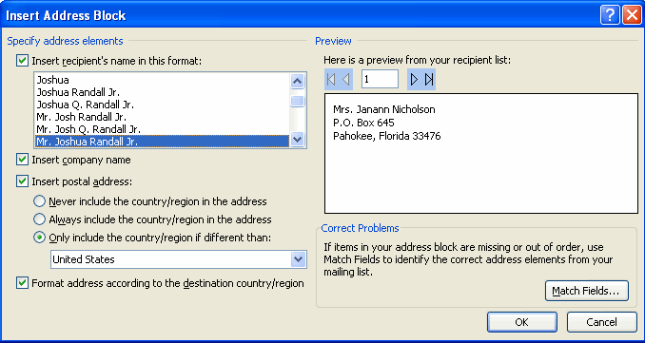
Your word document should now look like this:
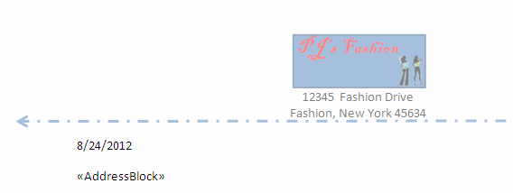
FYI: If you cannot add the address line, select Mailings, and then click Select Recipients. Select Use Existing List, and find where you saved your list.
Include a Greeting Line:
Double space down and click Greeting line located in the Mailing tab section.
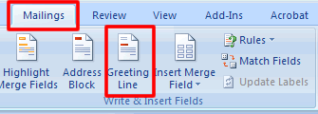
This opens the Insert Greeting Line dialog box. Choose the format you want your greeting to be in.
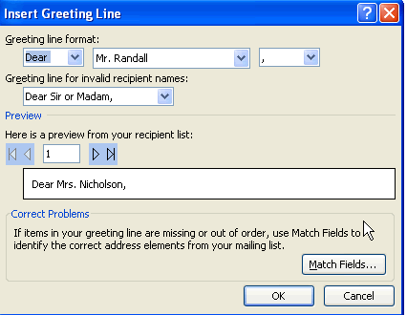
Your document should now look like this:
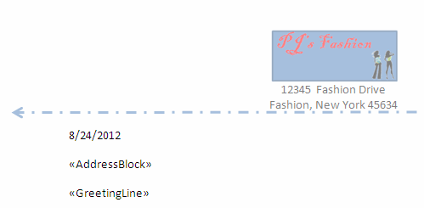
Insert Recipients First Name and Last Name:
You need to include the recipients first and last name somewhere in your letter to make it sound like you personally wrote him/her that letter. You will start the letter off with the recipients name. Double space down and with the Mailing tab selected click Insert Merge Field and select First Name, hit the space bar, then select last name. <<First_Name>> <<Last_Name>> should appear where you want the name to appear.
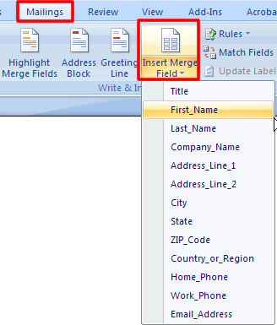
Your word document should now look like the graphic below:
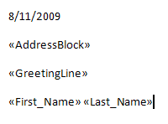
Include an E-Mail Merge Field:
You also need to include somewhere in you document a place to place the person's e-mail address. To include this in the letter click Insert Merge Field, then e-mail and <<Email_Address>> should appear.
The letter below is what I typed to give you an example. Yours should be different.
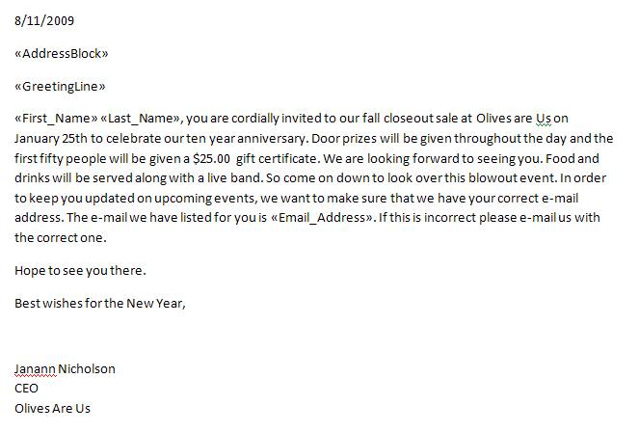
Preview Your Letters:
To preview your letters, with the Mailing tab selected click Preview Results then click the arrow keys to view all five of your documents.
