Create a Phone List
You want to create a list of phone numbers that will display the numbers for the region managers. Open a new document in Word 2010 and save it with the name LastName.Region Manager Phone Numbers.
Add the title Region Manager's Phone Numbers center aligned at the top of the page.
Type in the following information just as it appears below, or use names you make up yourself.
Change Line Spacing
Select all five names and on the Home tab, in the Paragraph group, click the Line Spacing button, then choose Remove Space After Paragraph: 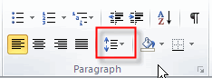

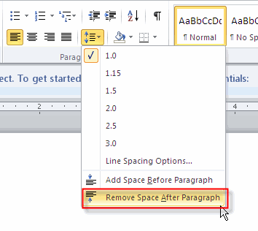
Set Tabs
With all five names still selected create a Right tab setting with dot leaders. With the Home tab selected in the Paragraph section click the more button.
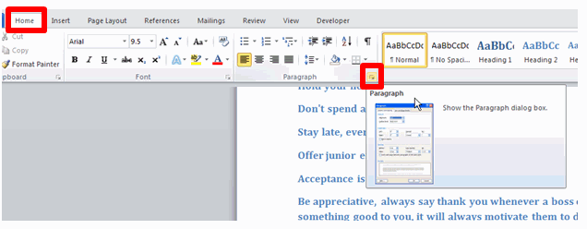
At the Paragraph dialog box click the Tab button.
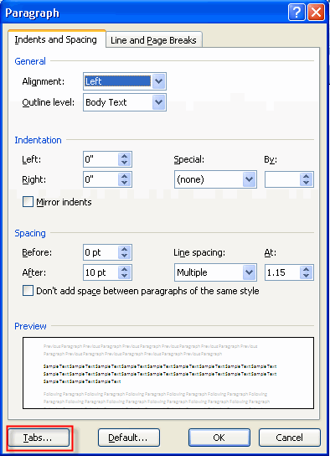
Type 6.5" in the Tab stop position, click the Right radio button and the 2nd options in the leader section, then click the Set button to set the tabs.
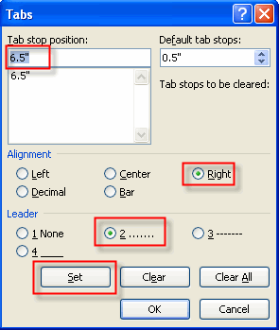
Press OK to finish.
Enter Phone Numbers
Place your cursor after the first name and press the tab key then type in the phone number. You can make up phone numbers for each of the employees. Place your cursor behind the second name and press the tab key then enter the phone number. Repeat until you have all phone numbers entered as shown below:
(Remember—the title is Region Manager’s Phone List. NOT Numbers to Post)
