Business Cards
Start a new document and name it Business Cards. To see an example of a completed business card click the link below:
Insert Logo:
With your cursor at the top of your document insert your logo on the page. I resized mine to 0.7 " high by 1.7" wide 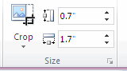. You should resize yours as close to 1 inches high by 11/2 inches wide. (With the logo selected go to the Picture Tools tab in the format section and change the size there)
Press the enter key to place your cursor on the line below your logo. Type in your fictitious address, phone and fax number, and website url.
While holding your left mouse down drag over both your logo and business data info.
Create Business Card Layout
With the logo and business data still selected, with the Mailing tab selected click Labels.
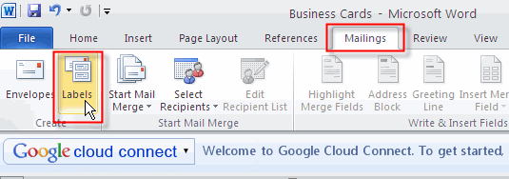
This opens the Envelopes and Labels dialog box. With the Labels tab selected click Options.
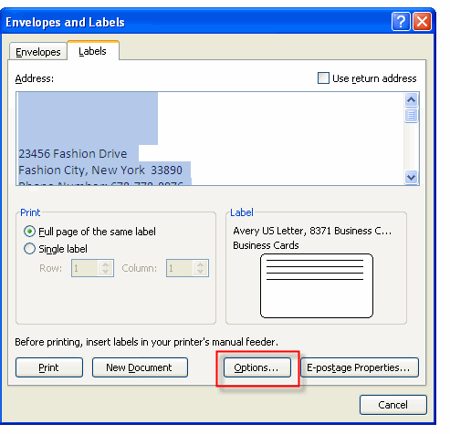
Notice that the business data appears in the Address section. The space that is shown above is the placeholder for your logo so do not try to move the address information up in the box. This will delete your logo.
Select Microsoft for Label Vendors and Business Cards (4th one) for the product number.
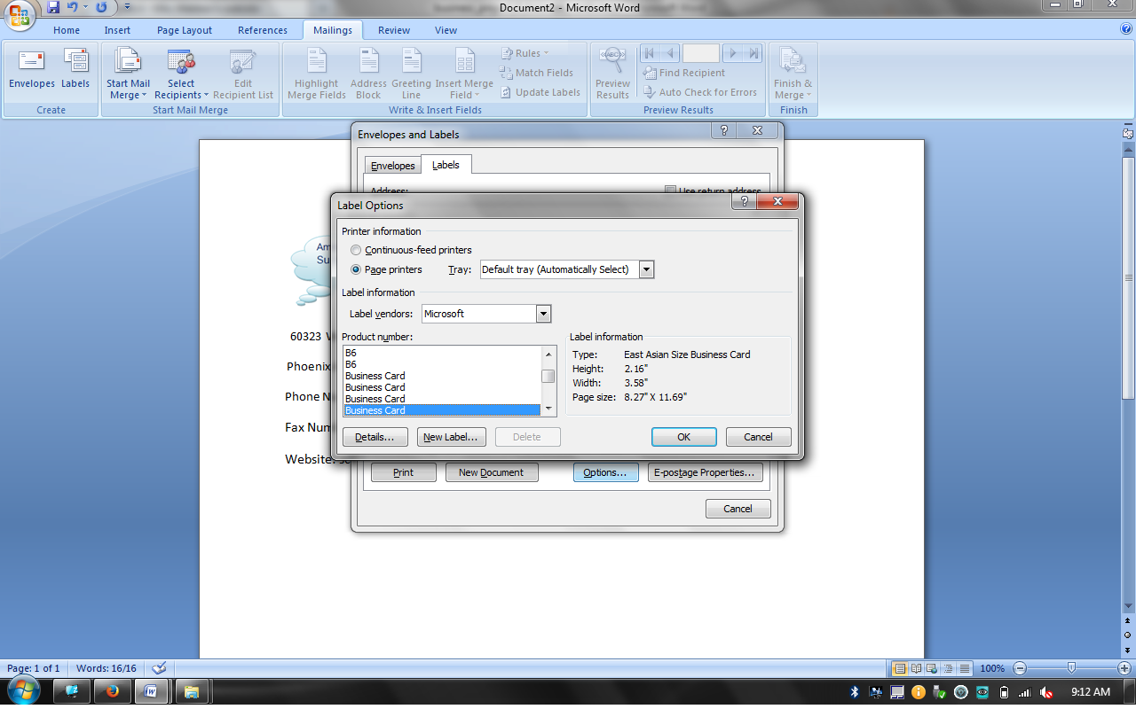

Click OK to set up the Labels layout and to take you back to the Envelopes and Labels dialog box. Make sure Full page of the same label is selected then click New Document.
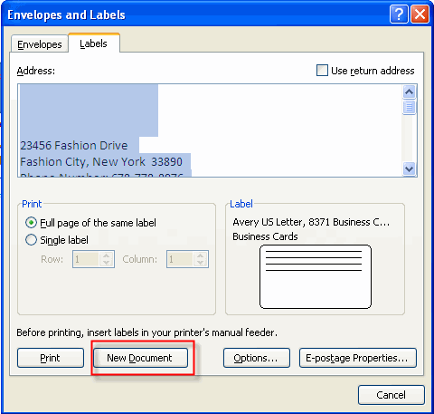
Your document should now look like this:
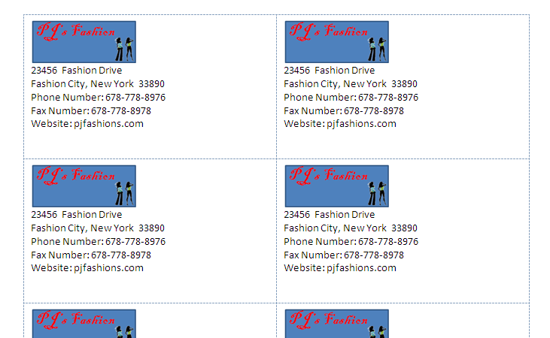
Add Fill Effect Page Background Color to Your Cards
Click back on the page. With the Page Layout selected click the Page Color icon then select Fill Effects.
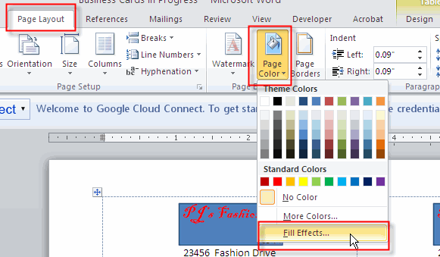
With the Pattern tab selected, click the 20 percent option (first column, third row) and select a Foreground and Background color that matches your logo.
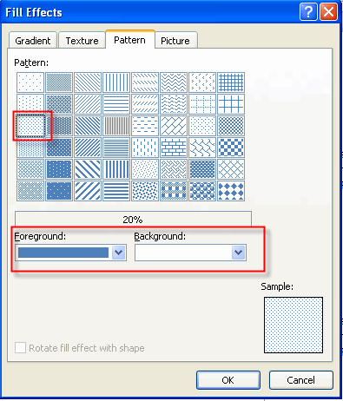
Your document should look similar to this:
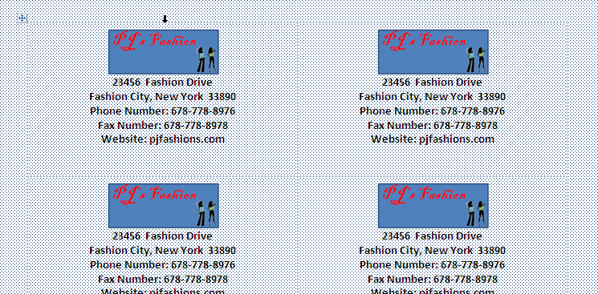
Add Page Border
With the Page Layout tab selected click Page Borders then select the Borders tab.
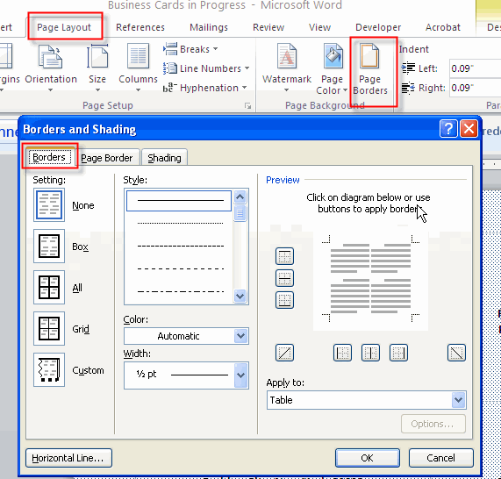
In the preview area click the six areas boxed in red. Your preview should look like the picture in the blue box.
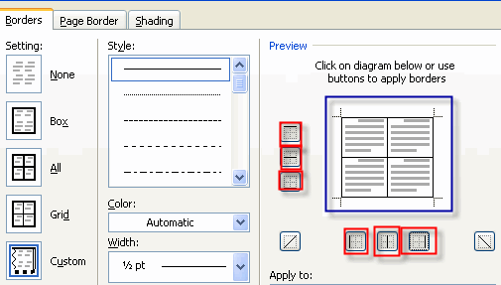
Select a Border Style, Color and Width
Select a style, color and width for your border and make sure Table is selected in the Apply to section.
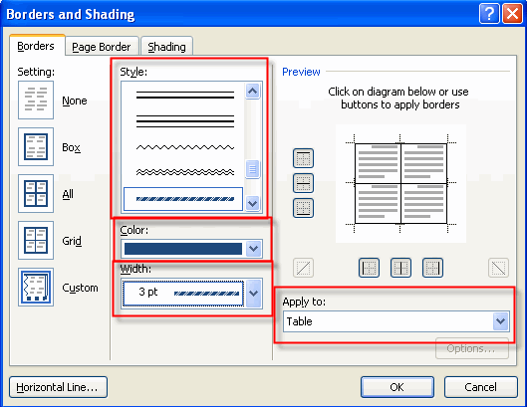
The last thing you need to do is to set the settings to All. Click OK to apply the Page Borders to the business card page.
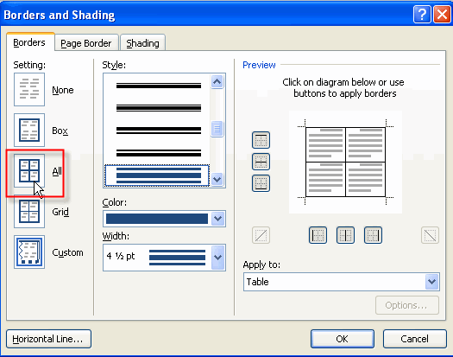
Your business cards should now look similar to this: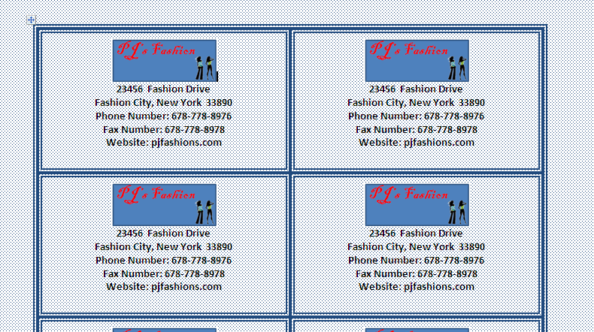
Resave your document.

