Creating a Company Letterhead
Start Word 2010. Start a new document and save the document with the name LastName.Letterhead.
You will create the letterhead in the header section of the document. To get to the header, with the Insert tab selected click Header then select Edit Header. You can also get to the header if you double click at the top of your document.
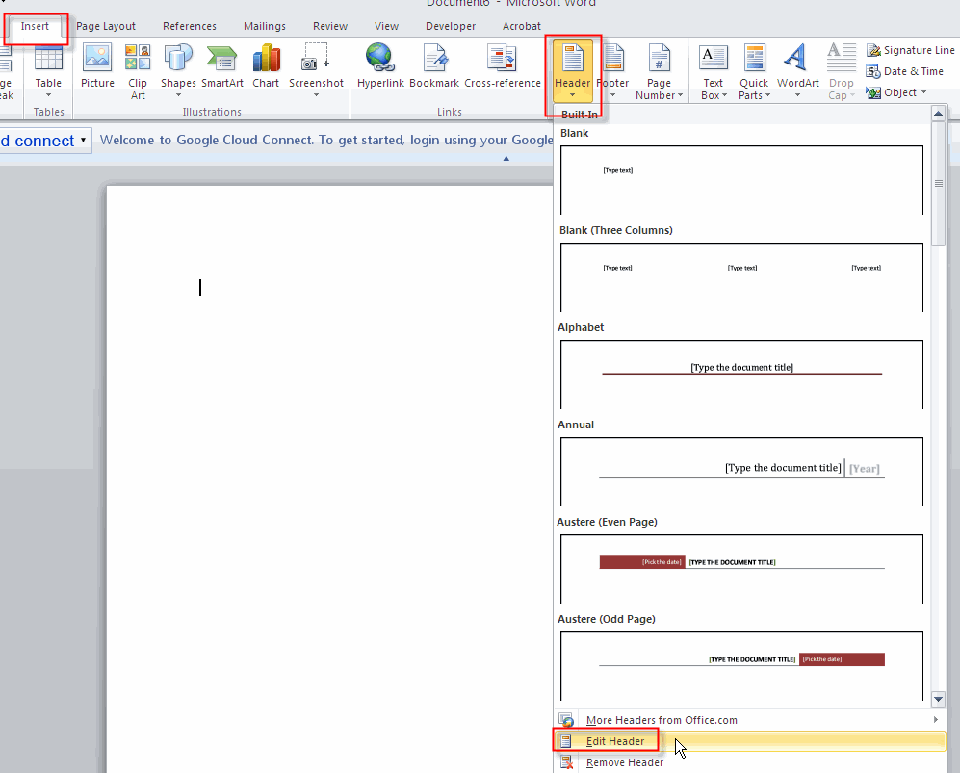
Your document should now look like this:
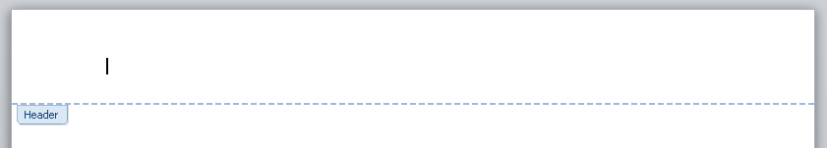
Insert and Resize Logo
Insert your logo (Insert > Picture) and center align it in the header (Home > ).
Your header should now look like this:
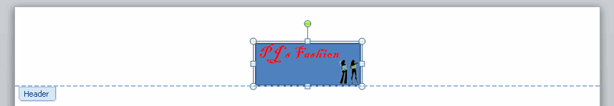
Make it smaller so that it doesn't appear so large by right clicking on the picture and selecting Size and Position.
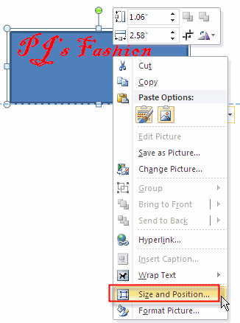
At the Layout dialog box you want to scale the picture down 50% while keeping the picture's ration to the original picture. Make sure that the Lock aspect ration and Relative to original picture size is checked. This will insure that the picture is not distorted when resized. In the scale height box select 50%.
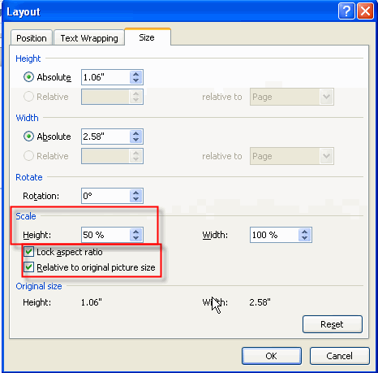
Your logo should now look like this:
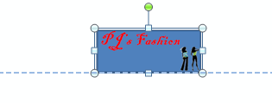
Add Address Information
Place your cursor beside the logo and hit the enter key. This will extend your header down the page. Type in a fictitious address for your company. The text should be single spaced. and center aligned. You do not need to include the title because the title appears in your logo. Your header should now look like this only with your logo and your fictitious address:
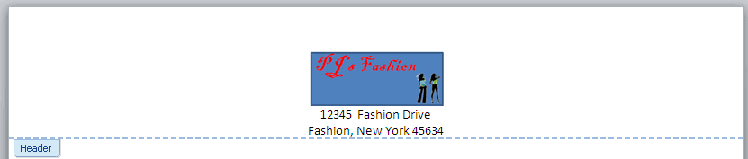
Draw a Horizontal Line Under Your Address, Apply Line Style, Color and Shape
You will place the horizontal line just under your address. With your cursor under your address, with the Insert tab selected click shapes then the double arrow line.
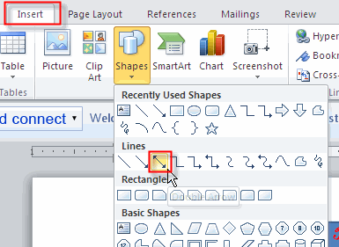
Now you will format the line. With the line still selected you will add a Line Style. Under Drawing Tools, on the Format tab, in the Shape Styles group, click the Quick Style that you want. To see more Quick Styles, click the More button:
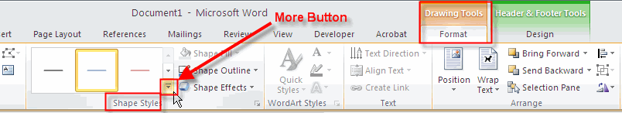
If you want a line dash style, with the line selected Under Drawing Tools, on the Format tab, in the Shape Styles group, click the arrow next to Shape Outline.
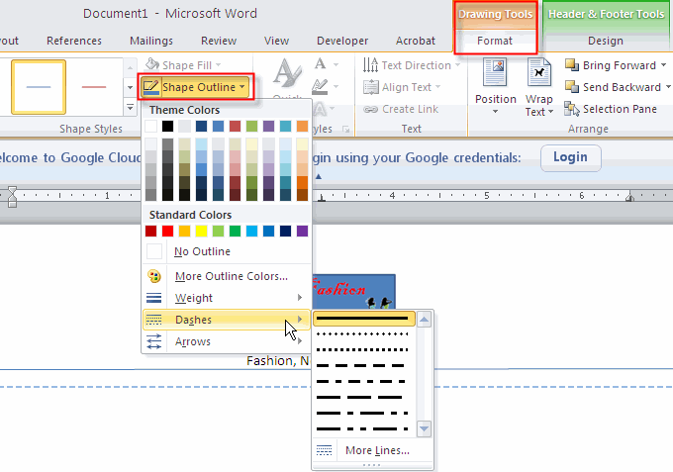
Change Line Color
To change the line color, with the line still selected, under Drawing Tools, on the Format tab, in the Shape Styles group, click the arrow next to Shape Outline, and then click the color that you want. To change to a color that isn't in the theme colors, click More Outline Colors, and then either click the color that you want on the Standard tab, or mix your own color on the Custom tab.
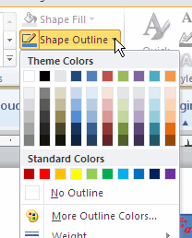
Change Line Weight (Thickness)
With the line still selected, under Drawing Tools, on the Format tab, in the Shape Styles group, click the arrow next to Shape Outline. Point to Weight, and then click the line weight that you want. To create a custom line weight, click More Lines, and then choose the options that you want.
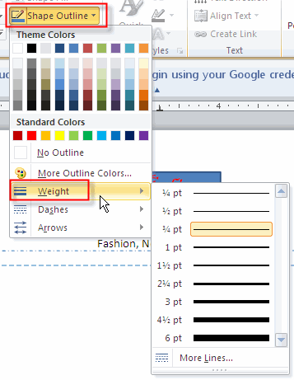
Double click outside of the header to exit the Edit Header. Your letterhead should only take up about 1/10 of your page. Imagine your page folded to make ten equal parts. Your address and arrow should only appear in the top 1/10th part of the page. Here is how mine turned out.
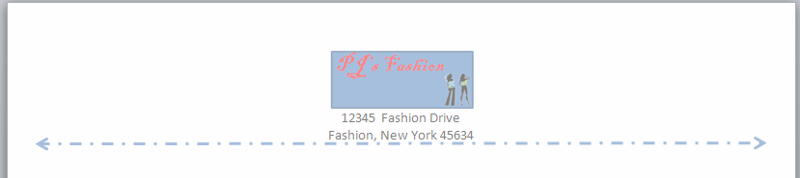
You need to move the header up, giving you more room in the document body. While still in the header section change the Header from Top form 0.5" to 0.02".

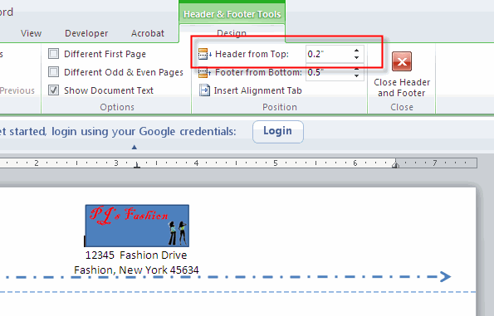
Save your document with the name Letterhead. Proofread and spell check your document.

