Create a Business Logo
Now you will create a logo that will be used in all of your document. It will need to contain 3 things; a shape, text, and a clipart graphic. When complete the logo should only be about 1 inches high and 2.5 inches wide
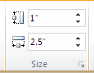.
Start a new Word Document. Save the document with the name LastName.Business Logo.
Add Shape
With the Insert tab selected select a shape from the drop down menu.
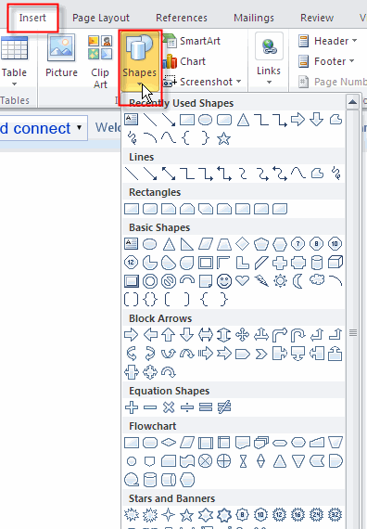
Make sure the shape conforms to the size restriction of 1 by 2.5. To see the size of the shape select the shape by clicking on it then with the Drawing Tools Format tab selected view the size in the size section. To change the size simply click on the down and up arrows on the right size of the numbers.
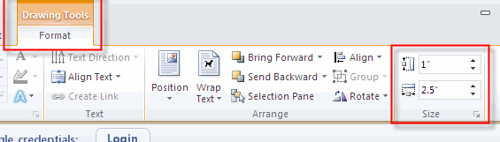
Change the Background Color
To change the color of your logo, select Drawing>Format. Select a style using the arrows, then clicking on the style you want.
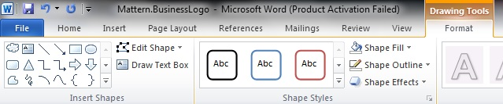
Add Text
To add text to the shape you will need to insert a text box. With the Insert tab selected click text box and select Simple Text Box.
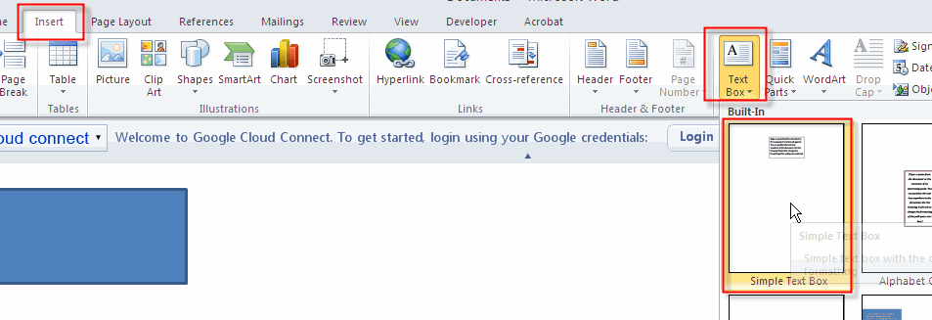
Type the text in the box. Choose the font, size and color of your choice.
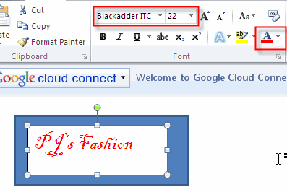
To get rid of the white background of the text box, click on the text box to select it then with the Drawing Tools format tab selected drop down the Shape Fill menu and select No Fill.
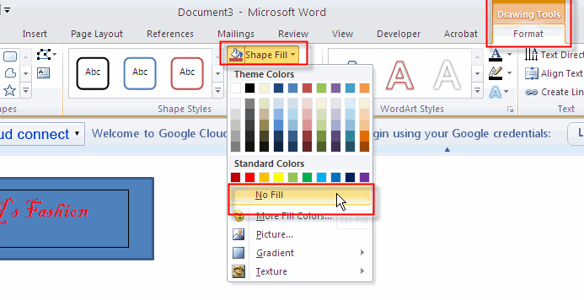
To get rid of the black stroke box around the text, select the Shape Outline button and select No Outline.
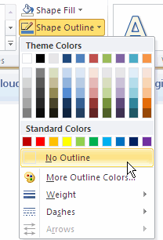
Add ClipArt
The last thing is to add clipart to the logo. It should be something that pertains to your business. With the Insert tab selected click the Clip Art button to open the clipart gallery.
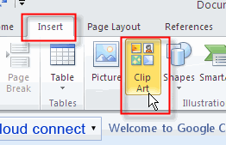
Type in a search word to populate the gallery with clipart that is related to your business.
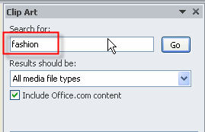
Find the one that best fits your business then click on it to insert it on the page. Resize it so that it will fit on top of your shape. Now you will need to format it so that it will go on top of the logo. This is called Text Wrapping.
Text Wrap
With the clipart still selected, make sure the Picture Tools Format tab is selected then drop down the Wrap Text menu and select In Front of Text.
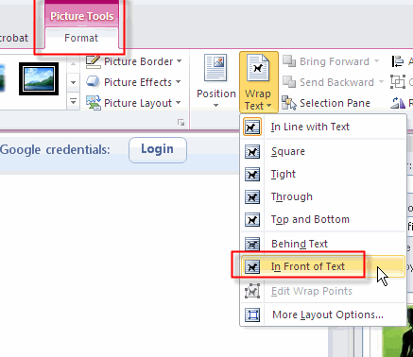
You can now drag your clipart on top of the logo. Notice the picture I have selected has a white background. I want to get rid of it.
Remove White Background
Select the clipart you want to get rid of the white background and with the Picture Tool Format tab selected click the Remove Background icon on the ribbon.
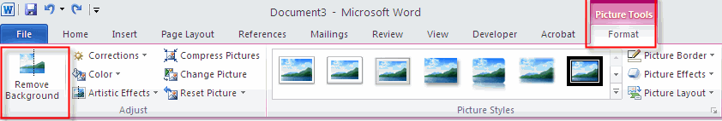
Click the Keep Changes to close the Background Removal box.
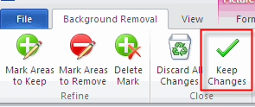
Here is how my logo now looks:
Save the Logo as a Picture File
Now you need to get it into picture format. On your keyboard click the Print Screen key
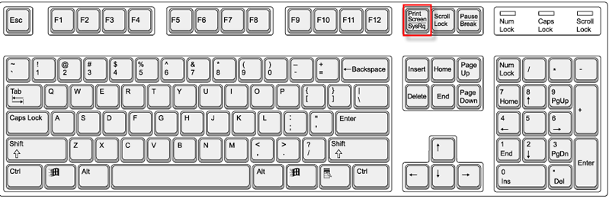
to bring up the print screen dialog box.
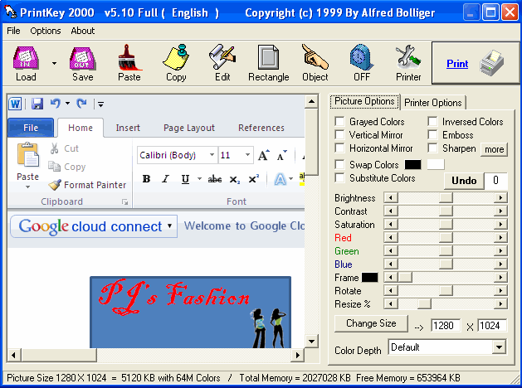
Select the rectangle 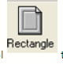, this will close the PrintKey box. Drag around your logo while holding down your left mouse button and release your mouse at the end of your selection. This should take you back to the print key dialog box where only your logo should now appear. Click the Save button and save the picture to your student folder.
