Create a SmartArt Graphic Detailing Your Business Name and Products
You will be creating business documents for your personal business. Before you get started you will need to come up with a name for your business as well as 6 categories of items you will sell. First you will need to create a chart outlining the categories as well as the business name.
Open Microsoft Word 2010 and a new blank document should appear.
Save the document with the name LastName.SmartArt Graphic.
In the new document and with the Insert tab click SmartArt to open the SmartArt gallery.
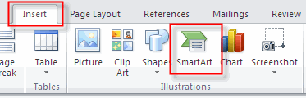
Choose a SmartArt graphic similar to the one below. It is found in the Cycle section and called “Basic Radial”.
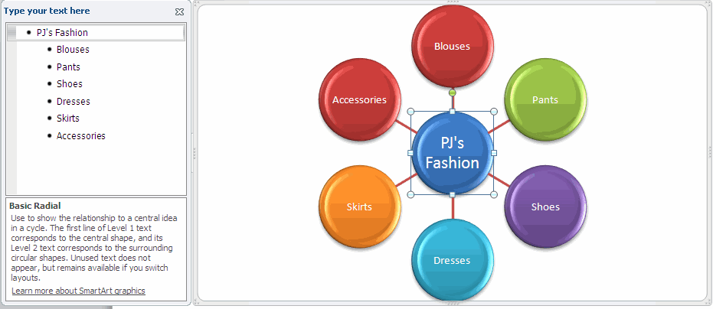

Add Text to the SmartArt Graphic
Make sure to enter your text in the Type your text here box, not on the SmartArt graphic. The center graphic should contain the name of your business. The six outside graphics should contain six categories of items you will be selling. FYI: To add additional graphics to your chart simply press the enter key.
Change Color
Change the color of the SmartArt Graphic by selecting the graphic and with the SmartArt Tools Design tab selected click the Change Colors button to view the color options.
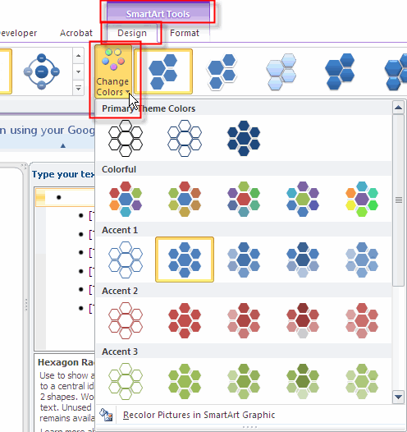
Add Shape Effect
With the SmartArt graphic still selected add a shape effect to the graphic. With the SmartArt Tools Format tab selected click the Shape Effects button to drop down the menu. Choose an effect to add to your graphic.
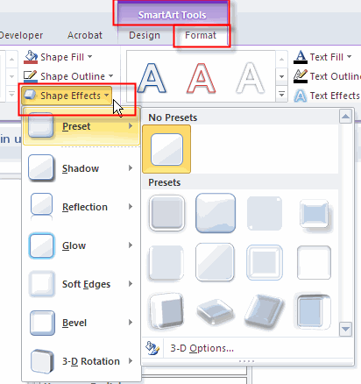
Add a Background Color
Now add a background color to your page. With the Page Layout tab selected click the Page Color button to view the color options. Select a color of your choice. Check out the Fill Effects section for additional color options..
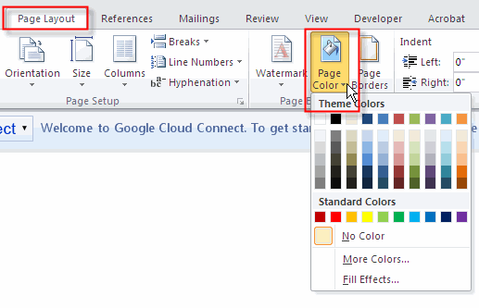
Add a Page Border
With the Page Layout tab selected click the Page Borders button to view the page border options.
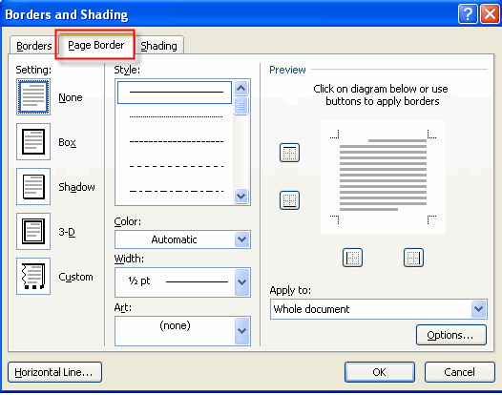
Select a border of your choice. Check out the Art section for additional border options.
Add ClipArt
With the Insert tab selected click ClipArt.
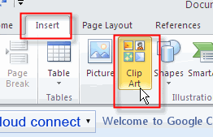
Type in a search word to populate the gallery with clipart that is related to your business.
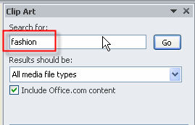
Find the one that best fits your business then click on it to insert it on the page.
Save it to your student folder.

